Link to the video: https://youtu.be/04yEGH3UCmQ
SVM is one of the most popular, versatile supervised machine learning algorithm. It is used for both classification and regression task. But in this thread we will talk about classification task. It is usually preferred for medium and small sized data-set.
The main objective of SVM is to find the optimal hyperplane which linearly separates the data points in two component by maximizing the margin .
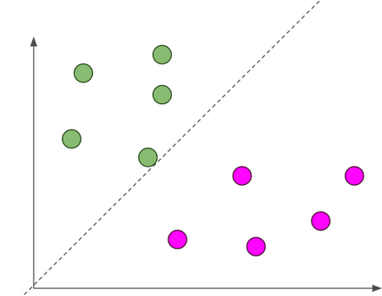
dotted line is hyperplane, separating blue and pink classes balls.
Don’t panic with the word ‘hyperplane’ and ‘margin’ that you have seen above. It is explained in details below.
Points to be covered:
1. Basic linear algebra
2. Hyper-plane
3. What if data points is not linearly separable ?
4. Optimal Hyperplane
5. How to choose optimal Hyperplane ?
6. Mathematical Interpretation of Optimal Hyperplane
7. Basic optimization term
8.SVM Optimization
Basic Linear Algebra
Vectors
Vectors are mathematical quantity which has both magnitude and direction. A point in the 2D plane can be represented as a vector between origin and the point.
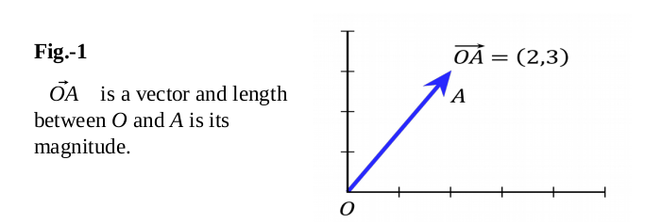
Length of Vectors
Length of vectors are also called as norms. It tells how far vectors are from the origin.
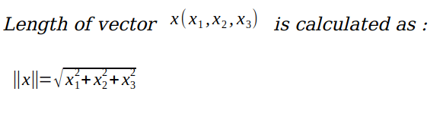
Direction of vectors
Direction of vector .
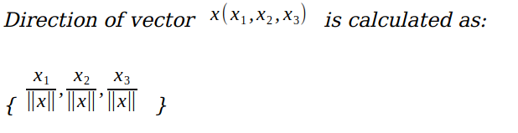
Dot Product
Dot product between two vectors is a scalar quantity . It tells how to vectors are related.
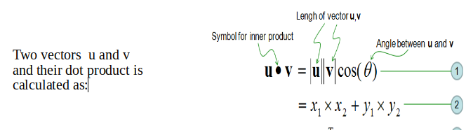
Hyper-plane
It is plane that linearly divide the n-dimensional data points in two component. In case of 2D, hyperplane is line, in case of 3D it is plane.It is also called as n-dimensional line. Fig.3 shows, a blue line(hyperplane) linearly separates the data point in two components.
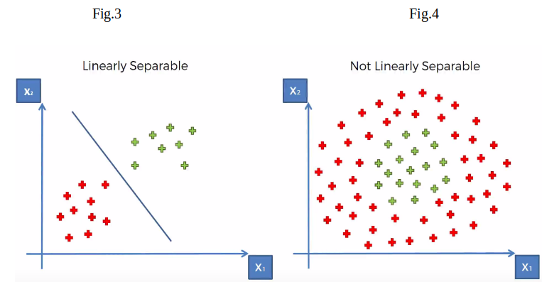
In the Fig.3, hyperplane is line divides data point into two classes(red & green), written as
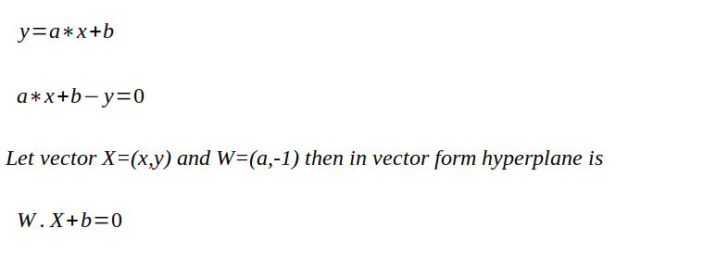
What if data points is not linearly separable ?
Look Fig.4 how can we separate the data-points linearly? This type of situation comes very often in machine learning world as raw data are always non-linear here. So, Is it do-able? yes!!. we will add one extra dimension to the data points to make it separable.
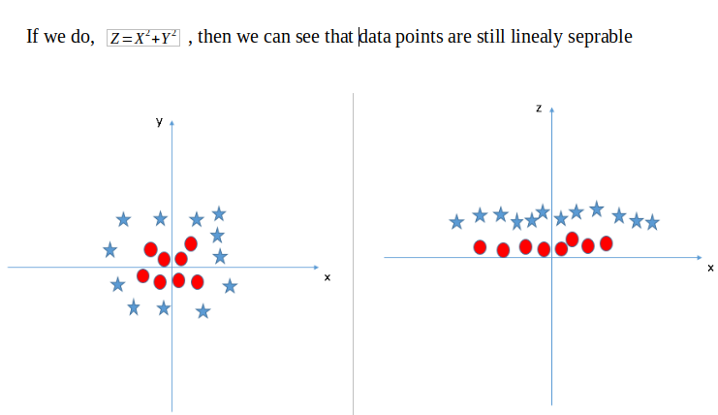
FIg.5
so , the above process of making non-linearly separable data point to linearly separable data point is also known as Kernel Trick, which we will cover later in details.
Optimal Hyperplane
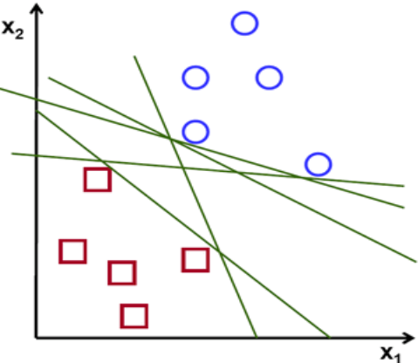
Fig.6
If you look above Fig there are numbers of hyperplane that can separate the data points in two components. So optimal hyperplane is one which divides the data points very well. So question is why it is needed to choose optimal hyper plane?
So if you choose sub-optimal hyperplane, no doubt after number of training iteration , training error will decrease but during testing when an unseen instance will come, it will result in high test error. In that case it is must to choose an optimal plane to get good accuracy.
How to choose Optimal Hyperplane ?
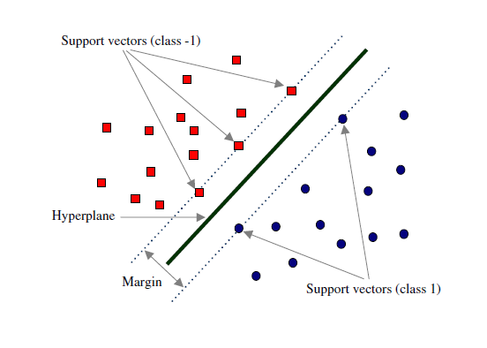
Fig.7
Margin and Support Vectors
Let’s assume that solid black line in above Fig.7 is optimal hyperplane and two dotted line is some hyperplane, which is passing through nearest data points to the optimal hyperplane. Then distance between hyperplane and optimal hyperplane is know as margin, and the closest data-points are known as support vectors. Margin is an area which do not contains any data points. There will be some cases when we have data points in margin area but right now we stick to margin as no data points lands.
So, when we are choosing optimal hyperplane we will choose one among set of hyperplane which is highest distance from the closest data points. If optimal hyperplane is very close to data points then margin will be very small and it will generalize well for training data but when an unseen data will come it will fail to generalize well as explained above. So our goal is to maximize the margin so that our classifier is able to generalize well for unseen instances.
So, In SVM our goal is to choose an optimal hyperplane which maximizes the margin.
— — — — — — —
Since covering entire concept about SVM in one story will be very confusing. So i will be dividing the tutorial into three parts.
Linear separable data points.
Linear separable data points II.
Non-linear separable data-points.
So, In this story we will assume that data points(training data) are linearly separable.Lets start,
Mathematical Interpretation of Optimal Hyperplane
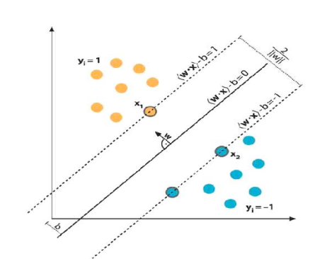
we have l training examples where each example x is of D dimension and each have labels of either y=+1 or y= -1 class, and our examples are linearly separable. Then, our training data is form ,
We consider D=2 to keep explanation simple and data points are linearly separable, the hyperplane w.x+b=0 can be described as:
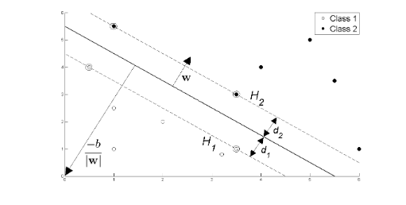
Fig.8
Support vectors examples are closest to optimal hyperplane and the aim of the SVM is to orientate this hyperplane as far as possible from the closest member of the both classes.
From the above Fig , SVM problem can be formulated as,
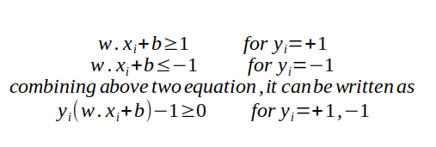
From the Fig.8 we have two hyperplane H1 and H2 passing through the support vectors of +1 and -1 class respectively. so
w.x+b=-1 :H1
w.x+b=1 :H2
And distance between H1 hyperplane and origin is (-1-b)/|w| and distance between H2 hyperplane and origin is (1–b)/|w|.
In a linear SVM, the distance of a hyperplane from the origin can be calculated using the concept of perpendicular distance (also known as margin) from a point to a hyperplane. The formula to calculate the distance of a hyperplane from the origin is based on the normalization of the hyperplane's coefficients.

Consider a hyperplane defined by the equation:
w⋅x + b = 0

Where:

w is the vector of coefficients (normal vector) of the hyperplane.
x is a point on the hyperplane.
b is the bias term.
The perpendicular distance (margin) from a point x to the hyperplane is given by:
Distance = |w⋅x + b| / ||w||

Where:

||w|| represents the Euclidean norm (magnitude) of the vector w.
If you want to calculate the distance of the hyperplane from the origin (0, 0), you can consider a point x at the origin:
x = (0, 0)

Plugging this into the distance formula gives:
Distance = |w⋅x + b| / ||w||
= |b| / ||w||

So, the distance of the hyperplane from the origin is |b| / ||w||.
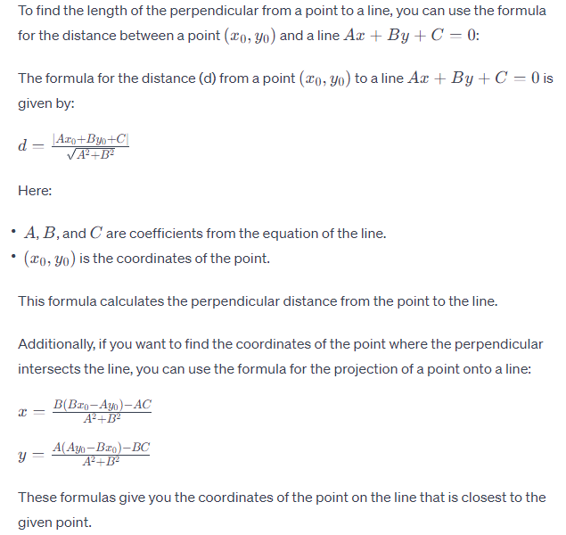
This formula makes sense intuitively: the distance of the hyperplane from the origin is proportional to the absolute value of the bias term b and inversely proportional to the magnitude of the vector w, which determines the orientation of the hyperplane.
So, margin can be given as
M=(1-b)/|w|-(-1-b)/|w|
M=2/|w|
Where M is nothing but twice of the margin. So margin can be written as 1/|w|. As, optimal hyperplane maximize the margin, then the SVM objective is boiled down to fact of maximizing the term 1/|w|,
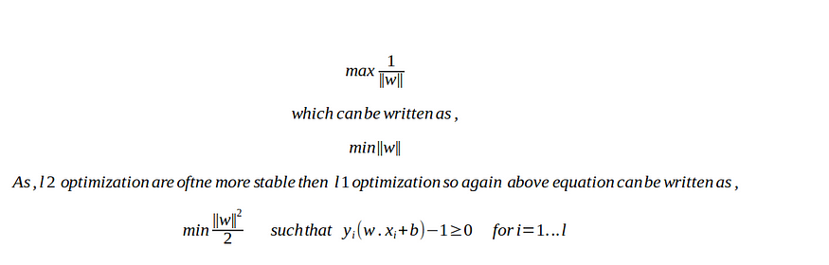
Basic optimization algorithm terms
Unconstrained optimization
Example will be more intuitive in explaining the concept,
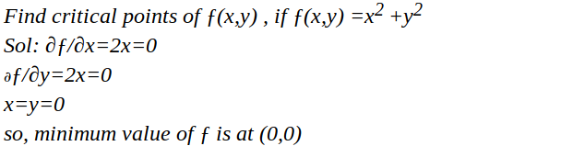
So, it is same that we used to do in higher school in calculus for finding maxima and minima of a function. Only difference is at that time we were calculating for univariate variable, but now we are calculating for multivariate variables.
Constrained optimization
Again it will become clear with an example,
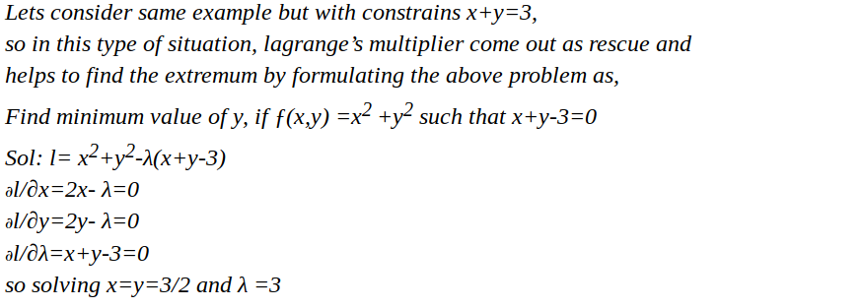
So basically, we calculate the maxima and minima of a function by taking into the consideration of given constraints on the variables.
Primal and Dual Concept
The concepts of primal and dual problems are fundamental in optimization theory and play a significant role in understanding the mathematical foundations of various algorithms, including Support Vector Machines (SVMs). Here's an overview of the primal and dual concepts:
Primal Problem:
The primal problem is the original optimization problem that we aim to solve. In the context of SVM, the primal problem involves finding the optimal hyperplane that separates the data points with the maximum margin. The primal problem seeks to directly optimize the parameters of the hyperplane, such as the weights and bias, while satisfying certain constraints. In SVM, the primal problem can be formulated as a quadratic optimization problem with linear constraints.
Dual Problem:
The dual problem is derived from the primal problem using a technique called the Lagrange dual transformation. It involves introducing Lagrange multipliers to formulate a new problem that is related to, but often simpler than, the original primal problem. The dual problem allows us to find an alternative solution to the same optimization problem. In SVM, the dual problem is expressed in terms of the Lagrange multipliers associated with the constraints.

Relationship Between Primal and Dual:
The primal and dual problems are connected through the Karush-Kuhn-Tucker (KKT) conditions. These conditions represent a set of equations that must be satisfied at the optimal solution of both the primal and dual problems. In SVM, solving the dual problem yields the Lagrange multipliers, which provide insights into the importance of individual data points (support vectors) and the structure of the decision boundary. The optimal solution of the primal problem can be obtained from the solution of the dual problem through these multipliers.
Advantages of Dual Problem:
The dual problem often offers advantages in terms of computation and interpretation. In SVM, solving the dual problem can be computationally more efficient, especially when using techniques like the Sequential Minimal Optimization (SMO) algorithm. Additionally, the dual problem provides insights into the sparsity of the solution, allowing for the identification of support vectors and understanding the impact of individual data points on the decision boundary.
Lets not get deep into these concept. Any optimization problem can be formulated into two way, primal and dual problem. First we use primal formulation for optimization algorithm, but if it does not yield any solution, we go for dual optimization formulation, which is guaranteed to yield solution.
Optimization
This part will be more mathematical, some terms are very high level concept of mathematics, but don’t worry i will try to explain each one by one in layman term.
To make you comfortable, Learning algorithms of SVM are explained with pseudo code explain below. This is very abstract concept in SVM optimization. For below code assume x is data point and y is its corresponding labels.
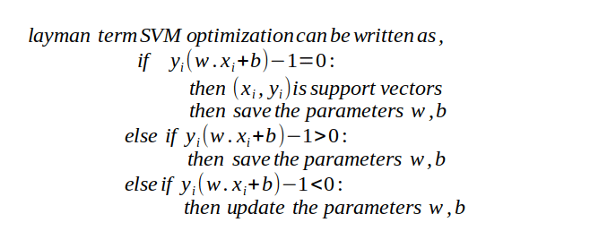
Just above you see learning process of SVM. But here is a catch, how do we update w and b ??
Gradient descent of course!!! — -BIG ‘NO’.
why not Gradient descent??
Imagine you're a teacher and you have two types of apples: red and green. You want to draw a line on a paper that separates these two types of apples as best as possible. This line is your "decision boundary." Now, you realize that the apples are a bit messy and not perfectly separable, so you want to draw this line in such a way that you have the maximum gap between the red and green apples. This gap is your "margin."
In the world of SVM, those apples are data points, and the line you draw is the hyperplane. The goal is to find the best hyperplane that separates the data points into different categories while having the largest possible margin between them.
Now, let's bring in the math. In order to find that best hyperplane, you need to do some math magic. You have to figure out the weights (like how much importance you give to each apple's color) and the bias (like where you put the line) that define the hyperplane.
But there's a twist. You want to be sure you're not just considering all the apples equally. Some apples might be super important in deciding where to draw the line because they're right at the edge of their group. These special apples are your "support vectors." They play a crucial role in finding that perfect line.
So, you use Lagrange multipliers, which are like helpers that tell you how important each apple is in finding the line. These helpers make sure that the hyperplane respects the margin and keeps those support vectors in mind.
But why bother with Lagrange multipliers? Because they help you transform the problem. Instead of directly finding the weights and bias for the hyperplane, you look for those helpers and use them to calculate the weights and bias later. This makes the math a bit easier and helps you find the best possible hyperplane that separates the apples in the coolest way.
SVM optimization problem is a case of constrained optimization problem, and it is always preferred to use dual optimization algorithm to solve such constrained optimization problem. That’s why we don’t use gradient descent.
Since it is constrained optimization problem Lagrange multipliers are used to solve it, which is described below, It looks like , will be more mathematical but it is not, its just few steps of finding gradient. We will divide the complete formulation into three parts.
In first we will formulate SVM optimization problem Mathematically
we will find gradient with respect to learning parameters.
we will find the value of parameters which minimizes ||w||
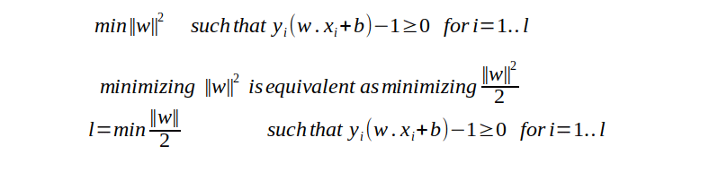
PART I — Problem formulation
The above equation is Primal optimization problem. Lagrange method is required to convert constrained optimization problem into unconstrained optimization problem. The goal of above equation to get the optimal value for w and b.
Lagrange's optimization problem and Lagrange multipliers are concepts from the field of mathematical optimization. They are used to solve constrained optimization problems, where you want to find the maximum or minimum of a function subject to certain constraints. Let's break down these concepts:

Lagrange's Optimization Problem:
Lagrange's optimization problem, also known as the Lagrangian optimization problem, is a method for solving constrained optimization problems. It was introduced by the mathematician Joseph-Louis Lagrange in the 18th century. The general form of a constrained optimization problem is to maximize or minimize a function f(x) while satisfying certain constraints g(x) = 0.

The Lagrange's optimization problem formulates this as follows:
Maximize or Minimize: f(x)
Subject to: g(x) = 0

Where x is a vector of variables, f(x) is the objective function you want to optimize, and g(x) represents the constraint equations that need to be satisfied.

Lagrange Multipliers:
Lagrange multipliers are coefficients introduced into the optimization problem to incorporate the constraints. They allow you to find the extreme values of a function while considering the constraints. In other words, they help you balance the optimization of the objective function with the requirement that certain conditions (constraints) are met.

Mathematically, if you have a constrained optimization problem of the form:
Maximize or Minimize: f(x)
Subject to: g(x) = 0

You introduce Lagrange multipliers (often denoted as λ) to create a new function called the Lagrangian:
L(x, λ) = f(x) + λ * g(x)

The Lagrange multipliers serve as weights that measure how changes in the constraint affect the objective function. The optimal solution occurs when the gradient of the Lagrangian with respect to both x and λ is zero.

The key insight is that the optimal solution for the constrained optimization problem will be at a point where the gradient of the objective function and the gradient of the constraint function are aligned, which is represented by the equations:
∇f(x*) + λ∇g(x) = 0 (for optimizing f(x))
g(x*) = 0 (for satisfying the constraint)

In the context of Support Vector Machines (SVMs), Lagrange multipliers play a significant role in solving the dual problem and finding the optimal hyperplane that maximizes the margin while satisfying the constraint that data points are correctly classified. These multipliers help identify support vectors and contribute to the determination of the final decision boundary.
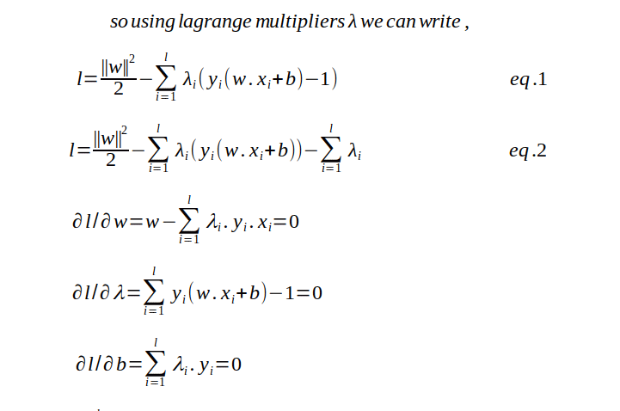
PART II — — — finding the gradient with respect to w ,b and lambda.
May be above equation is looking tricky? but it is not, its just high school math of finding minima with respect to variable.
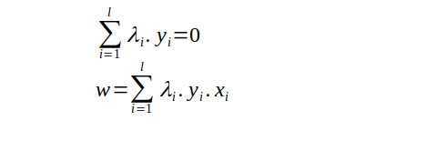
PART III — — — — we will get the value of w
As,from the above formulation we only able to find the optimal value of w and that is to dependent on λ, so we need to find the optimal value of λ also. And finding optimal value of b needs both w and λ. So finding the value of λ will be the important for us.
so how do we find the value of λ???
Above formulation is itself a optimization algorithm, but it not helpful to find the optimal value. It is primal optimization problem. As we read above that if Primal optimization doesn’t result in solution, we should use dual optimization formulation, which has guaranteed solution. Also when we move from primal to dual formulation we switch minimizing to maximizing the loss function. Again we will divide the complete formulation into three parts to easier to understand.
Problem formulation and substitution value from primal
Simplify the loss function equation after substitution
final optimization formulation to get the value of λ
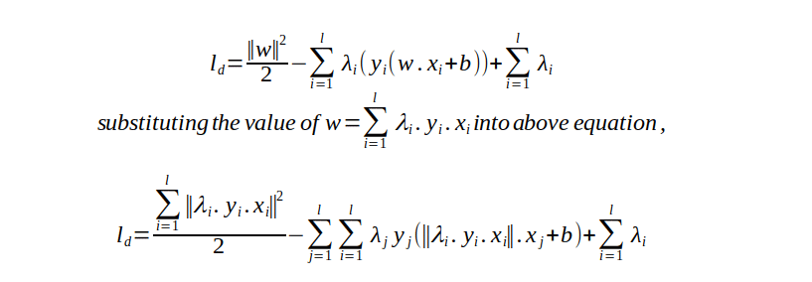
PART I — — — — Formulation from primal and Substitution
Above equation is a dual optimization problem. The equation are looking scarier because of substitution of value of w.
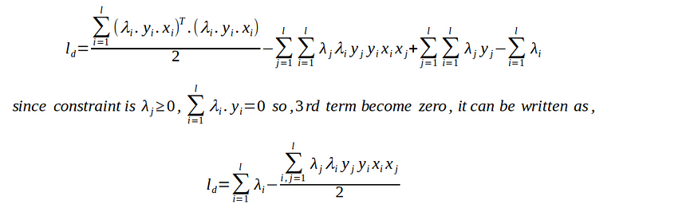
PART II — — — — — — — — — Simplification
It is simplified equation of above dual optimization problem.
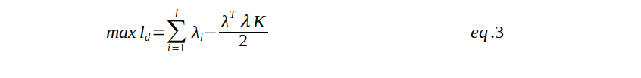
PART III — — — — — -Final optimization
So this is the final optimization problem, to find the maximum value of λ. Here one more term K is there, which is nothing but dot product of input variable x. (This K will be very important in future when we will learn about kernel trick and non-linear data points).
Now How do we Solve the above problem??
Above maximization operation can be solved with the SMO ( sequential minimization optimization) algorithms . There are also the various library support online for this optimization. Once we get the value of λ we can get w from below equation
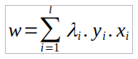
and using value of w , λ we will calculate b as following,
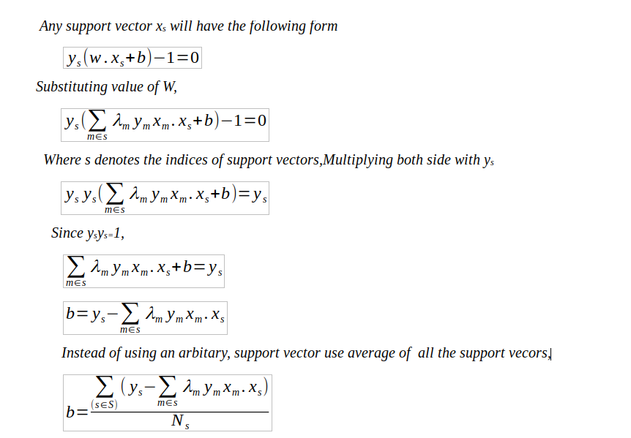
As we now have the value for both w and b , then optimal hyperplane that can separates the data points can be written as,
w.x + b = 0
And a new example x_ can be classified as sign(w.x_ +b)

